

Attribution Data Instructions
2026 Maternity Survey

May 2026

Picker
Picker is a leading international health and social care charity. We carry out research to understand individuals’ needs and their experiences of care. We are here to:
- Influence policy and practice so that health and social care systems are always centred around people’s needs and preferences.
- Inspire the delivery of the highest quality care, developing tools and services which enable all experiences to be better understood.
- Empower those working in health and social care to improve experiences by effectively measuring, and acting upon, people’s feedback.
© Picker 2026

Published by and available from:
Picker Institute Europe
Suite 6, Fountain House,
1200 Parkway Court,
John Smith Drive,
Oxford OX4 2JY
Tel: 01865 208100
Email: Info@PickerEurope.ac.uk
Website: picker.org

Registered Charity in England and Wales: 1081688
Registered Charity in Scotland: SC045048
Company Limited by Registered Guarantee No 3908160

Picker Institute Europe has UKAS accredited certification for ISO20252:2019 (GB08/74322) via SGS and ISO27001:2022 ((certificate number 23715) via Alcumus ISOQAR. We comply with Data Protection Laws including the General Data Protection Regulation, the Data Protection Act 2018 and the Market Research Society's (MRS) Code of Conduct.

Contents
1. About these instructions 4
2. Check you have the final version of your sample file 5
3. Download the Attribution Data Spreadsheet 6
4. Find out if you have electronic records for determining antenatal or postnatal care 7
Do you have appropriate antenatal records? 7
Do you have appropriate postnatal records? 7
5. Providing attribution data using electronic records 8
Antenatal care 8
Postnatal care 8
6. Providing attribution data using the postcode method 10
Determine which postcodes your trust provides maternity services to 10
Add your list of postcodes to the Attribution Data Spreadsheet 11
Complete the antenatal column 11
Complete the postnatal column 12
7. Checks to attribution data before submission 13
Checks to conduct before attempting to submit a file 14
8. Uploading Attribution Data 16
Overview: getting started 16
A: Menu-bar 16
B: Overview 16
Uploading your attribution file 17
Resolving queries 19
Step 1: On the query resolution page, you can scroll down to a table which gives further details about the queries that have been found, which will look like the following: 19
Step 2: Resolving an ‘Error’ 20
Step 3: Resolving a ‘Check’ or ‘Historic’ Check 20
Submitting the sample to the SCC 21
Review of the sample by SCC 21
Types of queries 21
What happens next? 23
9. Questions? 24

1. About these instructions
These instructions detail the process for checking and submitting the Attribution Data for the 2026 Maternity Survey using the online sample checking platform established for the NHS Patient Survey Programme. The purpose of this process is to identify maternity service users who received their antenatal and/or postnatal care from your trust. This information allows us to determine whether the care described in the antenatal and postnatal sections of the questionnaire refers specifically to your trust. By attributing responses to the trust in such a way, we can provide more scored data for benchmarking, thereby allowing trusts to use the results to improve services across the whole maternity pathway.
These instructions are designed to be used by trusts delivering the survey in partnership with an approved contractor and trusts delivering the survey in-house.
Efforts have been made to ensure that the information provided is reasonably comprehensive. It is, however, necessary to supplement this handbook with a small number of complementary documents. These are:
- The Attribution Data Spreadsheet: This is the template that should be used to submit attribution data regarding antenatal check-ups and postnatal care.
- The Survey Handbook: Which contains detailed information about the processes for preparing for and running the survey.
- The Sampling Instructions: Which contains detailed information about the drawing and submitting of samples.
The most recent versions of these documents can be downloaded from the NHS surveys Website: https://nhssurveys.org/surveys/survey/04-maternity/.
IMPORTANT! Please remember that no service user contact details should ever be shared with the Survey Coordination Centre - this would be a breach of the Section 251approval.
**The window for submission of your attribution file (and any subsequent queries/follow-ups) opens on 18 May and closes on 15 June**
If you have any queries about the contents of these instructions, please contact the Survey Coordination Centre (SCC) at Picker at: maternity@surveycoordination.com.

2. Check you have the final version of your sample file

During this exercise, you will be entering your Trust code, the Patient Record Numbers (PRNs) and possibly the postcode data (if using the postcode method) from your sample into the Attribution Data Spreadsheet. Before you start, contact your contractor, if you are using one, to check that you have the final, approved version of your sample file. This is very important.

If you are using a contractor, they may correct small errors in your sample file after you submit it to them. Therefore, you may not have the most up-to-date version of your file. Please ask them to transfer it to you if possible.
If you are doing the survey in-house, please double check you are using the version that was approved by the SCC, and not a version where people have been removed from the sample or an earlier version.
You need to have the final version of your sample file because the SCC checks your attribution data against your final sample file to make sure all of the records match up. During data analysis, we merge your attribution data with your sample data, and we need to be completely sure we are assigning the correct antenatal and postnatal information to the correct maternity service users.
In previous years, several trusts did not use the final version of their sample data when completing the Attribution Data Spreadsheet. This meant that there were extra cases included, or missing cases excluded. As a result, the SCC had to send queries to these trusts, which slowed down the approval process and created more work for the trusts involved.

3. Download the Attribution Data Spreadsheet
Download the Attribution Data Spreadsheet (available from https://nhssurveys.org/surveys/survey/04-maternity/) and save it as NHStrustcode_Maternity2026_AD.
Now, copy your Trust code, Patient Record Number and Postcode variables (if using the postcode method) from the final version of your sample data into the third tab of the spreadsheet (labelled ‘Data’).
DO NOT enter any identifiable data (i.e. names, NHS numbers, addresses) into the Attribution Data Spreadsheet. Postcodes can be added where needed during the compilation process but the postcode columns (C and D) in the ‘Data’ tab, and the ‘Postcode Boundary’ tab need to be deleted before submission to the SCC.

4. Find out if you have electronic records for determining antenatal or postnatal care
Wherever possible, information from your electronic records should be used to complete the Attribution Data Spreadsheet. To determine whether you have appropriate electronic records, please make sure you understand what we mean by antenatal and postnatal care.

Do you have appropriate antenatal records?
Check whether you have an electronic record of whether or not each maternity service user in your sample received their antenatal check-ups from your trust.
This means whether your trust employed the midwife/midwives that saw a service user during their pregnancy for appointments checking the progress of their pregnancy, usually including checking blood pressure and urine. In many cases these check-ups would have taken place in the community, although for some (particularly higher risk) pregnancies, they may have taken place at the hospital and/or by a doctor rather than a midwife.
If the antenatal care your trust provided to a service user related to visits to the hospital for scans or blood tests only, and they received their antenatal check-ups from a different trust, this means your trust did not provide their antenatal care for the purposes of this exercise.

Do you have appropriate postnatal records?
Check whether you have an electronic record of whether or not each maternity service user in your sample received their postnatal care in the community from your trust.
This means whether your trust employed the midwife/midwives that provided postnatal care to a maternity service user at home/in a clinic in the first four weeks after the birth.

5. Providing attribution data using electronic records
If you do not have appropriate electronic antenatal or postnatal records for ANY of the service users in your sample, skip ahead to Section 6.
If you have electronic records for antenatal and/or postnatal care fitting requirements in Section 4 for at least some service users, complete this section.

Antenatal care
Using your electronic records of antenatal check-ups, fill in Column E of the ‘Data’ tab within the Attribution Data Spreadsheet (‘Antenatal check-ups provided by your trust?’), using the codes below. Please note you will need to refer to your trust’s ‘booking information’ to help you with this.
- Enter 1 for maternity service users who did receive their antenatal check-ups from your trust AND were booked in to deliver at your trust before week 25 of their pregnancy.
- Enter 0 for maternity service users who either:
  - did not receive their antenatal check-ups from your trust.
  - received some of their antenatal check-ups from your trust BUT were not booked in to deliver at your trust until 25 weeks pregnant or later.

Postnatal care
Using your electronic records of postnatal care in the community, fill in Column F of the ‘Data’ tab within the Attribution Data Spreadsheet (‘Postnatal care in the community provided by your trust?’), using the codes below. Please note you will need to check the service user’s address details to see if they moved address within six weeks of giving birth.
- Enter 1 for maternity service users who did receive their postnatal care in the community from your trust.
- Enter 0 for maternity service users who either:
  - did not receive their postnatal care in the community from your trust.
  - received some of their postnatal care in the community from your trust, BUT you are aware that they moved to a different trust within six weeks of giving birth.
What’s next?
Where you have used the electronic method to provide details on antenatal AND postnatal care, enter code 1 in Column G of the ‘Data’ tab in the Attribution Data Spreadsheet (“Which method did you use for this attribution exercise?”).
If some maternity service users are missing a value at Column E and/or F, carry on to Section 6 to fill in any gaps using the postcode method.
If you have now filled in Columns E and F for EVERYONE in your sample, delete the postcode columns (C and D), the ‘Postcode Boundary’ tab and the ‘Guidance’ tab.
Skip ahead to Section 7.

6. Providing attribution data using the postcode method
If you have appropriate electronic antenatal and postnatal records for EVERYONE in your sample, skip ahead to Section 7. For now, you can ignore Column D (‘Postcode match’).

The postcode method should only be used to complete the Attribution Data Spreadsheet in cases where you do not have appropriate electronic antenatal or postnatal records for some or all maternity service users in your sample. The main steps involved in this section are listed below. The remainder of this section provides more detailed information for each of the steps below:
- Create a list of postcodes that your trust delivers maternity services to.
- Copy and paste this list of postcodes to the Attribution Data Spreadsheet in the ‘Postcode Boundary’ tab. IMPORTANT! Make sure the format of the data exactly matches the postcode data already included in Column C in the ‘Data’ tab otherwise the formula for the ‘Postcode match’ column won’t work. For example, postcodes should be in the format ‘AB8 3YP’ and not ‘AB83YP’.
- Use the results automatically provided in the ‘Postcode match’ column (D) and your trust’s booking information to complete/fill in gaps in the antenatal column of the Data tab.
- Use the results automatically provided in the ‘Postcode match’ column and the service user’s address details to complete/fill in gaps in the postnatal column of the ‘Data’ tab.
- IMPORTANT! Please delete the postcode columns (C and D) as well as the ‘Postcode Boundary’ tab and the ‘Guidance’ tab before submitting the file to the SCC.
If you have a more accurate method of determining who lives within the geographical area your trust provides maternity services to (for example by using CCG codes), please use this method instead and notify the SCC at maternity@surveycoordination.com that you have done so.

Determine which postcodes your trust provides maternity services to
Create a list of the postcodes that your trust has a contract to deliver maternity services to (i.e., antenatal check-ups and postnatal care in the community). If this information is not held electronically, we suggest you speak with your community midwife manager or community midwifery team as they will have knowledge of the specific geographical areas that they cover. You may also find it useful to check with your trust’s antenatal clinic manager.

Does your trust’s boundary overlap with another trust’s?
In some cases, trust boundaries may overlap with those of a neighbouring trust. If there are some postcodes where you are not sure whether your trust or a neighbouring trust provides antenatal or postnatal care, please do not include these postcodes in your list.

Add your list of postcodes to the Attribution Data Spreadsheet
Enter your list of postcodes into the fourth tab of the Attribution Data Spreadsheet (labelled ‘Postcode Boundary’).
The spreadsheet will now automatically match these postcodes against residential postcodes from the sample, which you should have already pasted into the second tab (labelled ‘Data’, column C) along with the rest of your sample information. In the ‘Data’ tab you will see that Column D (‘Postcode match’) has been populated with a ‘YES’ or ‘NO’ for each row. A ‘YES’ indicates that the maternity service user lives in one of the postcodes in your list, and a ‘NO’ indicates that they do not.
Postcode format
The list of postcodes you enter in the second tab must be in EXACTLY the same format as the residential postcodes in the sample, otherwise the matching formulae will not work.
If you get error messages in Column D or ‘NO’ for every case in Column D, please check your postcodes for extra spaces or other formatting differences.

IMPORTANT! Please delete the postcode columns (C and D) as well as the ‘Postcode Boundary’ tab before submitting the file to the SCC.

Complete the antenatal column
Fill in Column E of the Attribution Data Spreadsheet (‘Data’ sheet) (‘Antenatal check-ups provided by your trust?’) for each service user in your sample (except where you have already completed this using electronic records), using the codes below. Please note you will need to refer to your trust’s ‘booking information’ to help you with this.
- Enter 1 for maternity service users who have a ‘YES’ in Column D AND were booked in to deliver at your trust before week 25 of their pregnancy.
- Enter 0 for maternity service users who either:
  - have a ‘NO’ in Column D.
  - have a ‘YES’ in Column D BUT were not booked in to deliver at your trust until 25 weeks pregnant or later.

Complete the postnatal column
Fill in Column F of the Attribution Data Spreadsheet (‘Postnatal care in the community provided by your trust?’) for each maternity service user in your sample (except where you have already completed this using electronic records), using the codes below. Please note you will need to check the service user’s address details to see if they moved address within six weeks of giving birth.
- Enter 1 for service users who have a ‘YES’ in Column D.
- Enter 0 for service users who either:
  - have a ‘NO’ in Column D.
  - have a ‘YES’ in Column D according to their postcode at the time of birth, BUT you are aware that they moved outside of your trust’s boundary within six weeks of giving birth.
What’s next?
Where you have used the postcode method to provide details on antenatal AND postnatal care, enter a code 2 in column G.
If for some maternity service users, you used the electronic method for either antenatal or postnatal care, and used the postcode method for the other users, please enter a 3 in column G.

IMPORTANT! Please delete the postcode columns (C and D) as well as the ‘Postcode Boundary’ tab before submitting the file to the SCC.

7. Checks to attribution data before submission
The first step of the process is to pull together the required data for the attribution data submission. For this, you will need to enter all the information relating to your attribution data in the ‘Attribution Data Spreadsheet’ and save this file as <NHStrustname_Maternity2026_AD>.
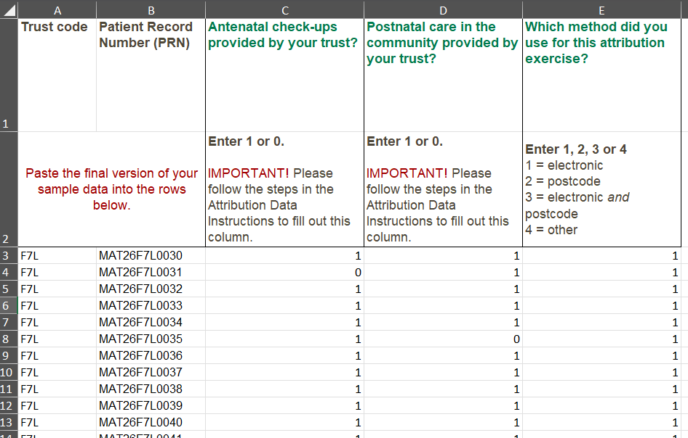
The table below shows an example of the populated spreadsheet for a trust using electronic records for all cases.

Page 12 of 20

Checks to conduct before attempting to submit a file
All submissions need to undergo a number of important checks before they can be submitted onto the secure file transfer server. This will help assess whether a file matches the guidance outlined – for example, if a column should only include a 1 or 0 as valid codes, is this reflected in what is being uploaded.
For further guidance on what checks are required, please refer to the second tab ‘Declaration form’ in the ‘Attribution Data Spreadsheet’ which outlines the checks each trust must complete before submitting their attribution data.
For completeness, the checks each trust must carry out before submitting the attribution data are split into two sections and outlined below.
- The first checks should be carried out before completing the attribution data spreadsheet:
  - Make sure you have read the 2026 attribution data instructions (this document) and get in touch with the SCC if you have any queries.
  - Make sure you are using electronic records wherever possible. If you do not have electronic records for all of your attribution data and you have used an alternative to the postcode boundary method for collating this data, make sure you have notified and checked this with the SCC.
- The second set of checks should be carried out before submitting the data through the secure file transfer server:
  - Check all cases have a trust code.
  - Check you have copied the full list of PRNs from the final, signed off version of your sample into the attribution data spreadsheet.
  - Check the PRNs are in the correct format – i.e., MAT26XXXNNNN, with XXX representing the trust code and NNNN the sample number.
  - Check the spreadsheet does not contain any duplicate PRNs.
  - Check the total number of PRNs match the original sample i.e. no mothers have been excluded since the sample was signed off by the SCC.
  - Check the cells for any mothers who have moved to another area or who have died or have been excluded since the sample was signed off by the SCC.
  - Check only codes 0 or 1 have been used for the ‘Antenatal check-ups’ column.
  - Check only codes 0 or 1 have been used for the ‘Postnatal care in the community’ column.
  - Check you have used electronic records to compile the attribution data wherever possible.
  - Check codes 1, 2, 3 or 4 have been used for the ‘attribution exercise’ column.
  - IF USING THE POSTCODE METHOD: Check you have copied the postcode data from the final, signed off version of your sample into the attribution data spreadsheet.
  - IMPORTANT! Check postcode (column C), postcode match (column D), the ‘Postcode Boundary’ tab and the ‘Guidance’ tab have been removed from the file before being uploaded. The SCC should not receive any postcode data.
  - Confirm no changes have been made to the column headings in the ‘Data’ tab.
  - Check all the necessary columns have been completed.
Finally, ahead of any attempted submission of attribution data, please check that you have fully read and adhered to the instructions outlined in this document.
The submission window this year opens on 18 May and closes on 15 June. This includes time for submission of your data, and time to respond to any queries/make any updates.

8. Uploading Attribution Data
Once you are happy with the attribution data and it has been checked against the listed checks, then you can start the submission process.
Please read these instructions carefully, as there is a new process for submission this year.

Overview: getting started
- Log in to the online sample checker via this link:
Welcome to the SCC Sample Checker tool (surveycoordination.com)

Your login details will be provided to you by the SCC. Please contact the SCC (maternity@surveycoordination.com) to provide an email address to be used as the username to access the platform. Once this has been confirmed, the SCC will share a temporary password which you will be prompted to change when you log in to the checker.

- Once you log in, you will be directed to the ‘2026 Maternity Attribution Data’ page for your trust:
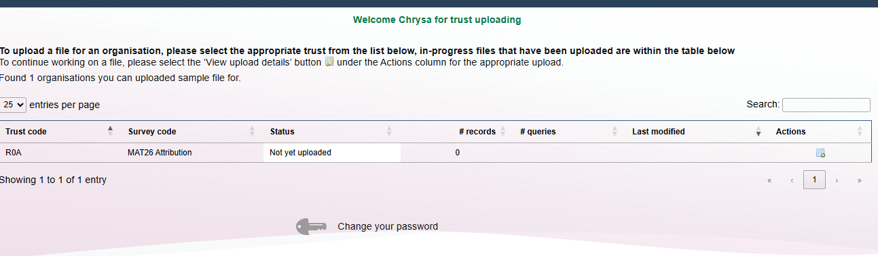

A: Menu-bar
- Home: This takes you back to the home page.
B: Overview
- Trust code: This is where you will be able to see your trust code. If your trust code is not showing, please contact maternity@surveycoordination.com.
- Survey code: This shows the survey code. For the 2026 Maternity Attribution Data the code is MAT26 Attribution.
- Status: This shows the current status of your trust’s sample, whether there are pending queries or whether it has been approved by the SCC.
- # records: How many records your trust’s uploaded sample file contains.
- # queries: Details of the number and type of queries that the uploaded sample has, whether an error or a check, notices and total open queries.
- Last modified: The date when the trust’s sample was last modified.
- Actions: Here you can find the button to upload the sample file or, if the trust already has a sample uploaded, to view the upload details.
Please note, the login has been linked to your trust for security purposes. The SCC will provide your login details, including a temporary password which you are able to change when you log in to the checker, by clicking on the ‘Change your password’ link at the bottom of the page.
If you have any questions, you must get in touch with maternity@surveycoordination.com.

Uploading your attribution file
Please make sure your file is ready for submission and that you have followed the instructions in the ‘Guidance’ tab of the Attribution Data Spreadsheet. Otherwise, the file will be rejected from the online platform.

Please check that the ‘Guidance’ tab and ‘Postcode Boundary’ tab have been removed before submission to the SCC.
Please also make sure that the ‘Postcode’ column (C) and ‘Postcode match’ column (D) in the ‘Data’ tab have been removed before submission to the SCC.

- To upload your sample click on the ‘upload file’ icon ( ) underneath the ‘Actions’ column. This will take you to the following screen:
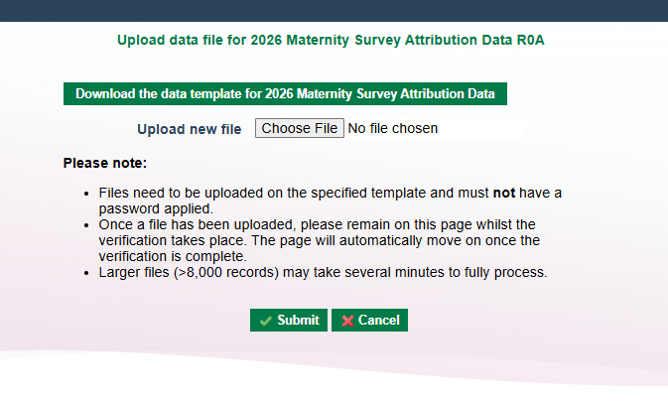
- Click on ‘Choose File’ to select the relevant file for upload. Please make sure that the file is a) not password protected and b) in the correct format i.e. that you have used the Attribution Data Spreadsheet.

- Click ‘Submit’ once the correct file has been chosen. Uploads may take a while depending on the size of the spreadsheet. Once the file has finished uploading, you will automatically be redirected to the query resolution screen as below:
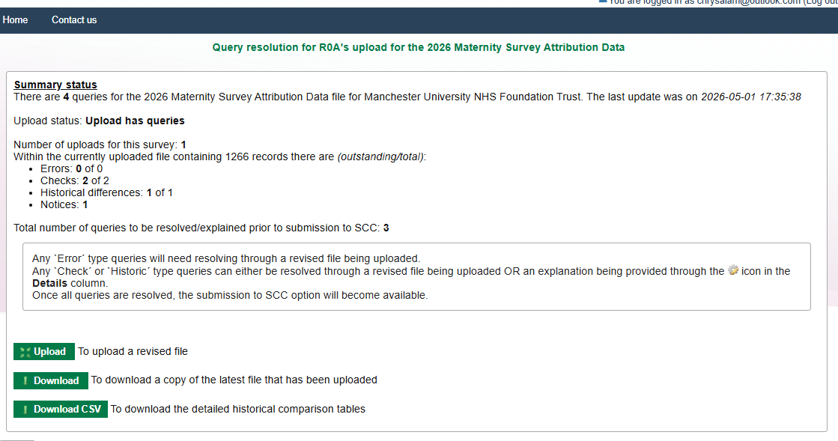


On this page, you are given a summary of the number of outstanding queries, as well as an option to download a copy of the attribution file or upload a revised version. You can also access this screen from the overview by clicking on the ‘Actions’ column icon.

Resolving queries

Step 1: On the query resolution page, you can scroll down to a table which gives further details about the queries that have been found, which will look like the following:

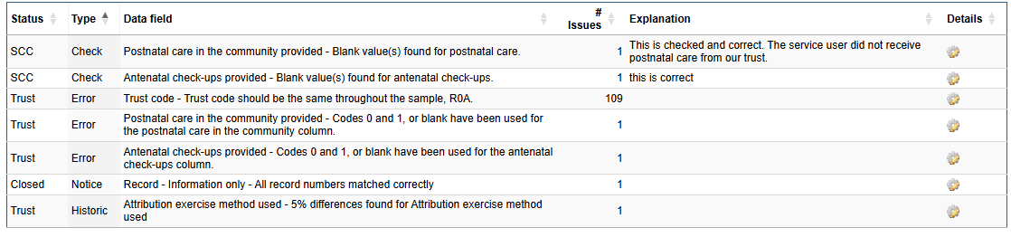
There are three different types of queries raised:
- Error – If an error appears this must be amended before the spreadsheet can be uploaded to the SCC. Errors include issues such as the total number of PRNs not matching the original sample submitted.
- Check – An issue which requires an explanation, such as checking that there were no blank cells for the postnatal care column.
- Historic – shift in the proportions from the previous survey year.
For more information on the type of errors and checks please see Table 1 below.
A: Query details
- Status: This is who the sample is awaiting action by.
- Type: The type of issue that has been raised; an error or a check.
- Data field: This displays which variable in the sample file the query relates to and the issue that has been found. For a full list of the checks that will be run and what each query message means, please see Table 1.
- # issues: How many issues were found.

- Explanation: When you provide an explanation for a check, it will display here (see Step 2 below).
- Details: Clicking on the icon provides more detail about which values are being queried. This is also where you can add your explanation for a check.
B: Overarching commentary
This box gives you the option to provide any additional commentary to be submitted to the SCC alongside your attribution data.

Step 2: Resolving an ‘Error’
- To resolve an error, you will need to reupload the corrected attribution file. You can do this by simply clicking on the ‘Upload’ button on the query resolution page, underneath the summary of the queries that were found.

This will take you back to the original upload screen where you can follow the same steps as before. Once again, you will be redirected to the query resolution screen if there are any problems with the file.

Step 3: Resolving a ‘Check’ or ‘Historic’ Check
- To resolve a check or historic, you can simply provide an explanation in the space provided on the query resolution page. Once you’ve clicked on the icon, a box will appear in which you can write an explanation for the check (please see screenshot below).
Please make sure your explanation includes as much information as possible. An explanation which says ‘this is correct’ will not be sufficient, especially if the check is in relation to historic changes:
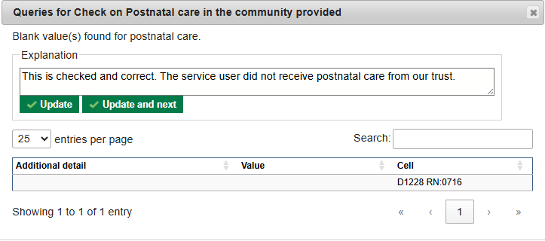
- Once you’ve typed the explanation in the box, click ‘update’, and your explanation will then appear in the ‘Explanation’ column on the query resolution page:
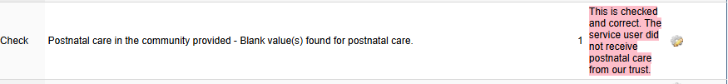

- Whilst the explanation is in red, this means that it has not been submitted to the SCC for review. To do this, you will need to click on ‘Save the explanation updates’, at the bottom of the query resolution page.
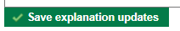

- Once the explanation has been saved, the ‘Status’ column will change to display SCC, meaning that the explanation is awaiting their review.

Submitting the sample to the SCC
- Once you have added clear explanations to all the ‘checks’, click on ‘Submit to SCC for acceptance’. This will send the SCC an email notifying us of the uploaded attribution data.

- The SCC will review and may either approve your submission or ask for further clarification. You can view the current status of the sample in the ‘Status’ column on the homepage.
  - If the SCC require further explanations the queries may be rejected, and additional comments will be added to the ‘shared overarching commentary’ box at the bottom of the page asking additional questions.
- You will receive an email detailing whether the attribution submission has been accepted or rejected.
- If rejected, it means there are errors in your submission. Please revise according to the SCC’s feedback and reupload your sample.

Review of the sample by SCC
To reduce the number of queries, please ensure the explanations provided to each of the ‘checks’ or ‘historic’ checks provide enough detail for the SCC to approve the sample.
For example, if there has been a 5% shift in antenatal or postnatal provision, it is important that you have checked this for accuracy, confirming this is correct, as well as commenting on what has influenced this shift. For example, change in total population or amendments in the data recording that has resulted in more accurate and better-quality data.

Types of queries
Below is a table containing information on all of the checks that are carried out by the SCC, with explanations on what exactly is being queried and the message that should be displayed on the online sample checker. Please note, SCC will query shifts of >5% across all variables.
Please note that for errors, these must be resolved, and a new attribution data file should be uploaded to the online checker. For checks and historic checks, you will need to provide an explanation for the SCC to review. The more information you can provide the better.
Table 1. Errors and checks
Query Type | Data Field | Message | Query Meaning
Errors – Amend to the sample file required
Error | Trust code | Trust code should be the same throughout the sample. | Different or blank trust codes found, please add correct codes.
Error | PRNs | List of PRNs should match the final, signed off version of the original sample submitted by the trust. | One or more submitted PRNs does not match the signed off version of the sample. Please provide a reason or re-upload.
Error | PRNs | Total number of PRNs should match the original sample. | The number of PRNs submitted does not match the signed off version of the sample. Please provide a reason or re-upload.
Error | Antenatal check-ups | Codes 0 and 1, or blank have been used for the antenatal check-ups column. | Codes other than 0 or 1 have been used in the antenatal check-ups column. Please correct and re-upload.
Error | Postnatal care | Codes 0 and 1, or blank have been used for the postnatal care in the community column. | Codes other than 0 or 1 have been used in the postnatal care column. Please correct and re-upload.
Error | Method of attribution | Codes 1, 2, 3 or 4 have been used for the method used for attribution exercise column. | Codes other than 1, 2, 3 or 4 have been used in the method of attribution column, or cells have been left blank. Please correct and re-upload.
Error | Postcode column | Only the five columns are included in the spreadsheet – no postcode column. | Postcode column is still in the spreadsheet. Please remove and re-upload.
Checks – Explanation from trust required
Check | Antenatal check-ups | Antenatal check-ups provided - Blank value(s) found for antenatal check-ups | There are blank cells in the antenatal check-ups column. Please provide a reason or re-upload if this is an error.
Check | Postnatal care | Postnatal care in the community provided - Blank value(s) found for postnatal care | There are blank cells in the postnatal care column. Please provide a reason or re-upload if this is an error.
Checks – Historical checks
Historic | Antenatal check-ups | >=5% shift in percentage of antenatal check-up codes since 2025 | There has been a >=5% shift in the percentage of antenatal check-up codes since 2025. Please provide a reason.
Historic | Postnatal care | >=5% shift in percentage of postnatal care codes since 2025 | There has been a >=5% shift in the percentage of postnatal care codes since 2025. Please provide a reason.
Historic | Method of attribution | >=5% shift in percentage of method used for the attribution exercise | There has been a >=5% shift in the percentage of method used for the attribution exercise since 2025. Please provide a reason.

What happens next?
Once the SCC receives an attribution data file, they will conduct some further checks and might have additional queries about your submission. If so, these will be raised via email to the nominated contact for the trust. This may require amendments to be made to the file and a revised version uploaded. Once the SCC are happy with the submitted data, they will confirm sign-off.
If you spot any issues such as errors or typos in your file after submitting the attribution data, please let the SCC know as soon as possible. You will not be able to upload another version until your original submission has been rejected.
All uploads must be completed and queries resolved while the window is open between 18 May – 15 June.

9. Questions?
For any questions, please contact the Survey Coordination Centre (SCC) based at Picker at maternity@surveycoordination.com.

Picker Institute Europe
Suite 6, Fountain House,
1200 Parkway Court,
John Smith Drive,
Oxford OX4 2JY
Tel: +44 (0) 1865 208100

info@pickereurope.ac.uk
picker.org

Charity registered in England and Wales: 1081688
Charity registered in Scotland: SC045048
Company limited by guarantee registered in England and Wales: 3908160

The instruction to remove the Guidance tab is new for this year, due to changes in the attribution data submission process. Further details are provided in Section 8.

